UTCTF 2023

A Network Problem - Part 3

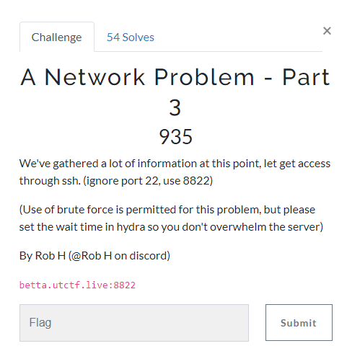

Note: the previous question is very important to this one make you can smb into the share folders or read previous write up

1. Scanned with nmap( from question we know we have to scan 8822)

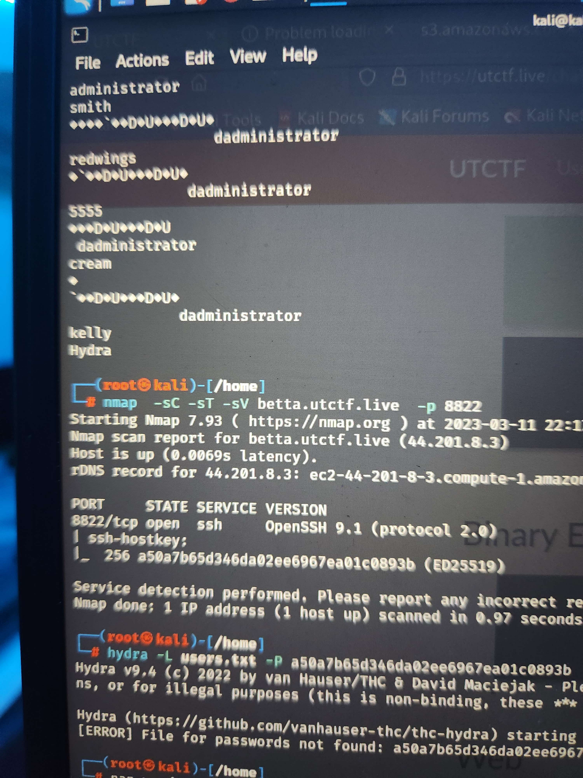

1. Here we learn they are using open ssh and we get the ssh-hostkey( note we still need username and password to ssh into it, and ed25519 is a protocol this is a key and not meant to be decrypted)
2. The question says that we are allowed to brute force it, lets make a list of users and passwords



1. We can use the clues in the notetoIT file from the last question, lets make a password wordlist based off the word “abracadabra”

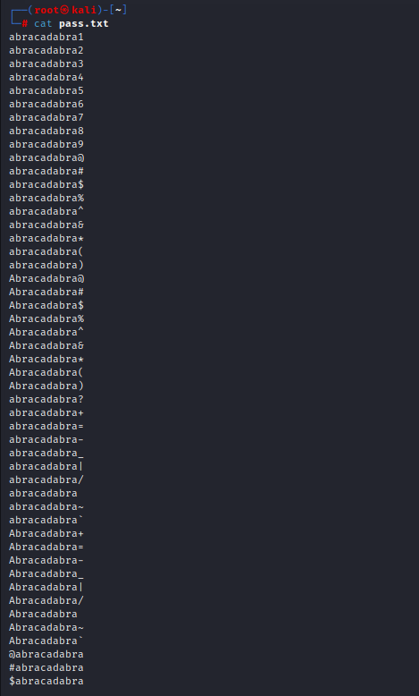

The hint is telling the users to add a special character so in my wordlist I put special characters at the end.

1. Next make a list of users

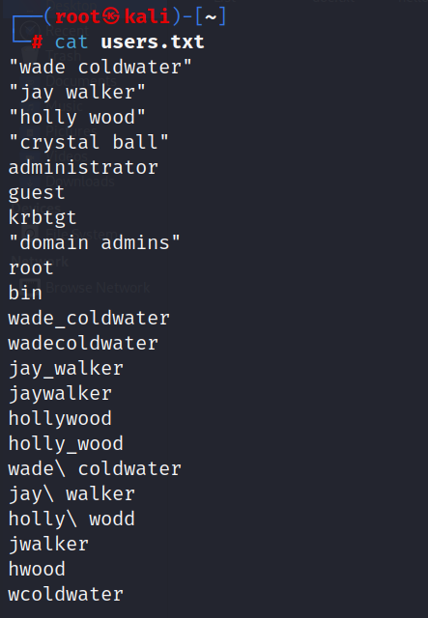

The hint gives us a list of users who use the password, so make a list of the possible usernames the people might have. Also note that the username list is case sensitive, you should test both uppercase and lowercase(not like my list)

1. Now that the list is made lets brute force the ssh using hydra using

hydra -L users -P wordlist.txt betta.utctf.live ssh -s 8822 -t 4

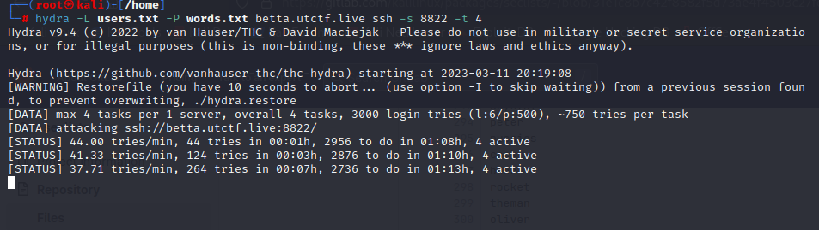

Note my password wordlist name changed from pass to words

Also note the t-4 limits how many requests we send, we do this so we don't overrun their servers, but can remove it if we want to send more requests and get results faster.

1. After hydra runs for awhile we get the password and username

The username we got was: wcoldwater

The password we got was: abracadabra$

1. With all this information we can ssh into the server, don't forget about the key we found earlier, you will get denied without it.

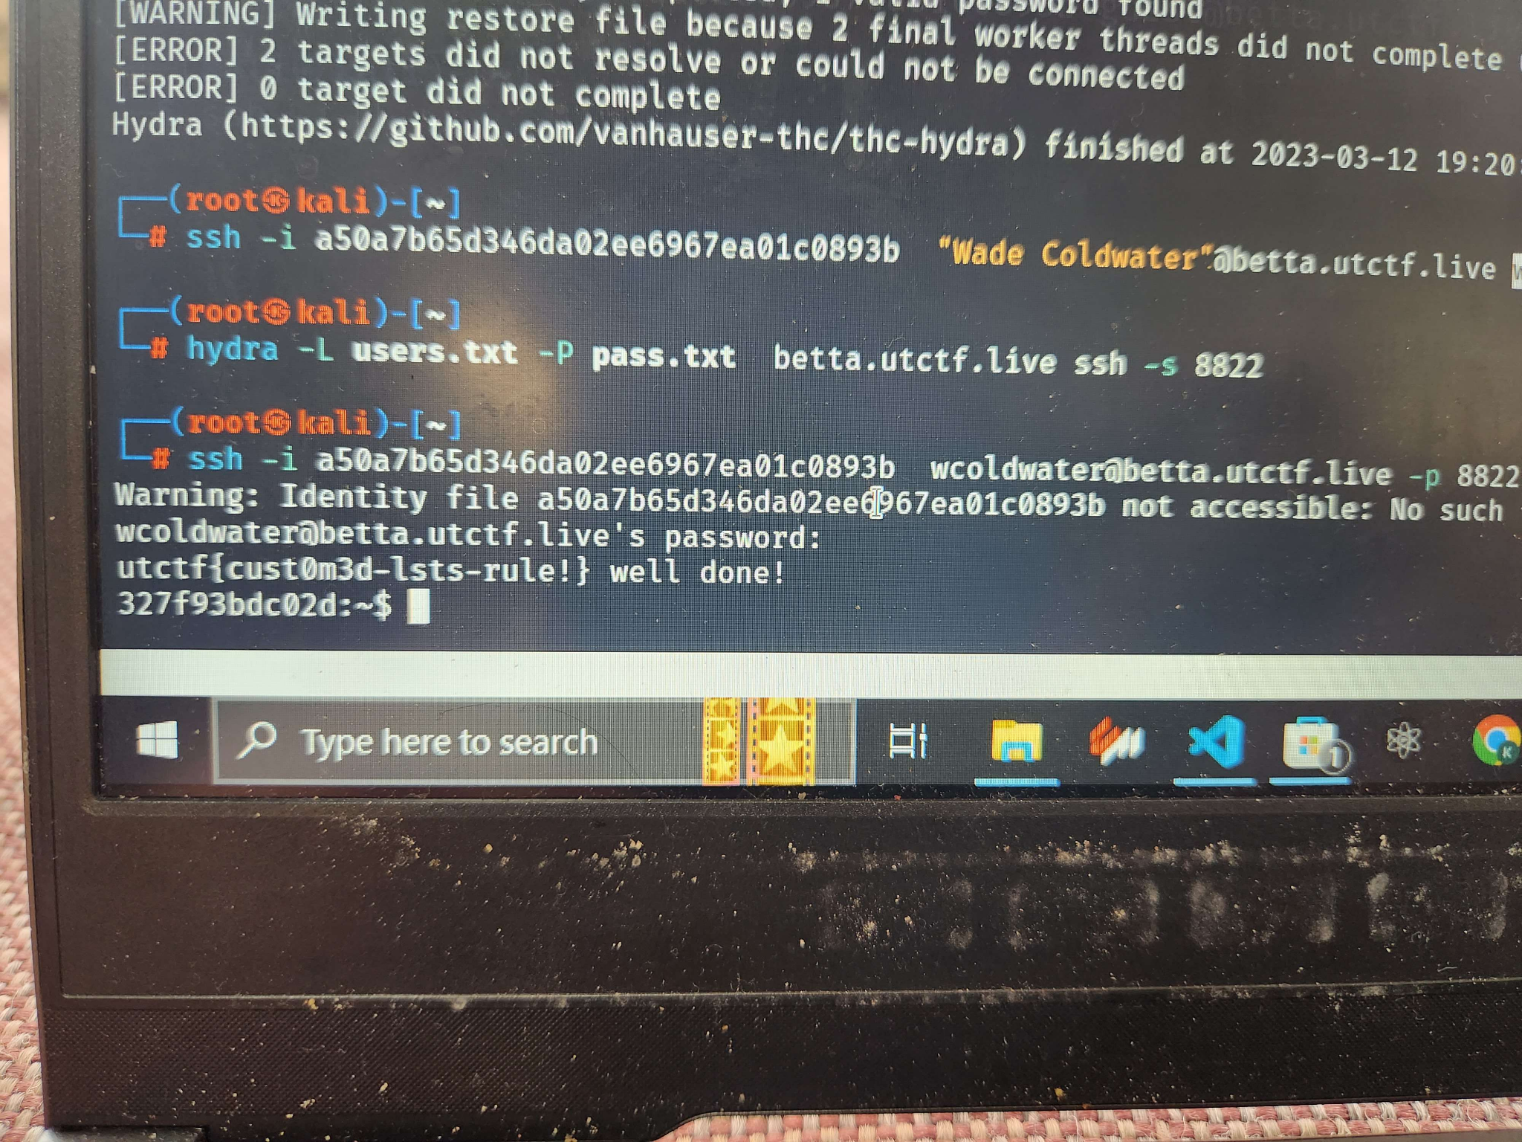



We got the flag